**Scenario 3 – Export Oriented**

**Scenario description**

This scenario applies the same filters as Scenario 2 (removal of outliers) but adds an **export intensity filter**, restricting the sample to export-oriented firms only. No restriction was applied on related party transactions (RPTs). The applied filters are:

* **Net worth > 0**
* **Persistent loss = 0**
* **Employee cost ≥ 25% of OR**
* **Service income ≥ 75% of OR**
* **Operating revenue between 1 and 30,000**
* **PLI between 0 and 50**
* **Export income ≥ 75% of OR**

Final sample sizes: **FY 2021-22: 778**, **FY 2022-23: 771**, **FY 2023-24: 682** firm-year observations.

**Results:**

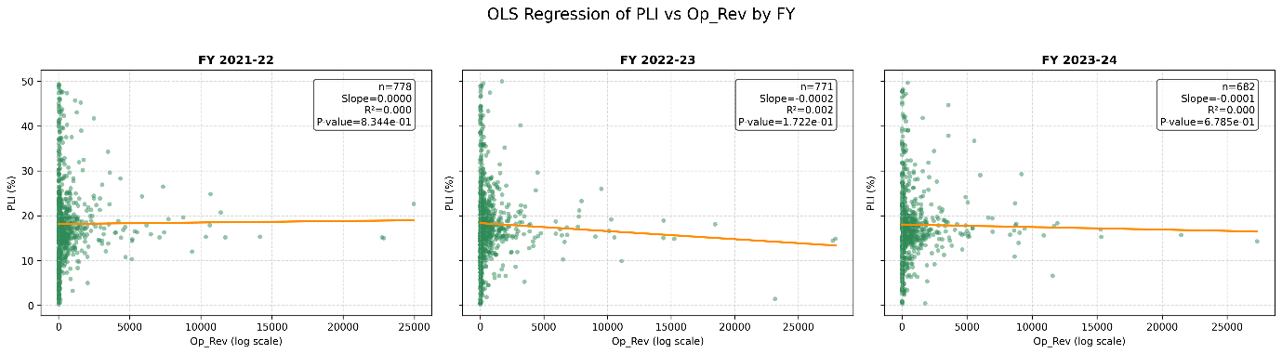

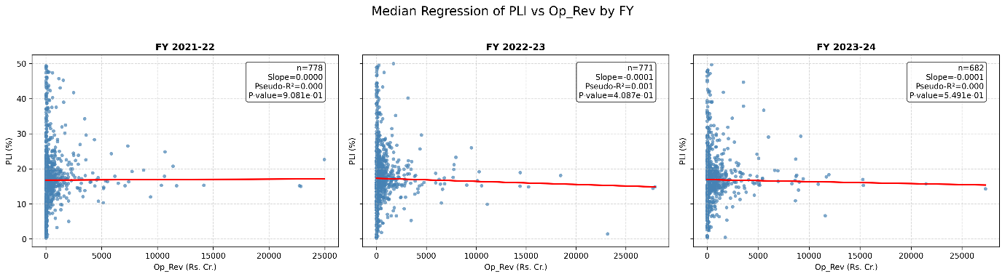

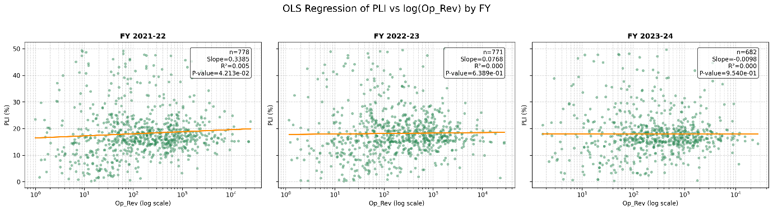

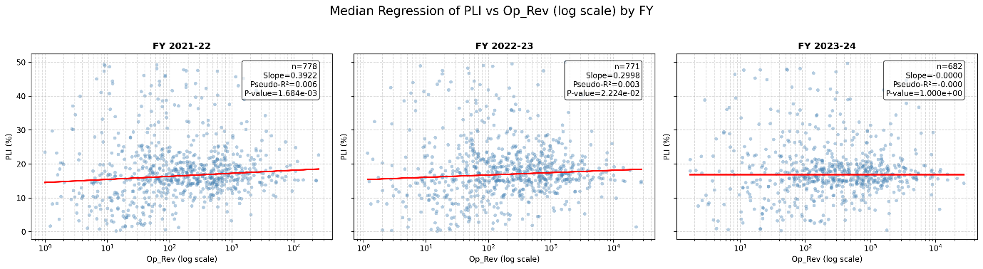

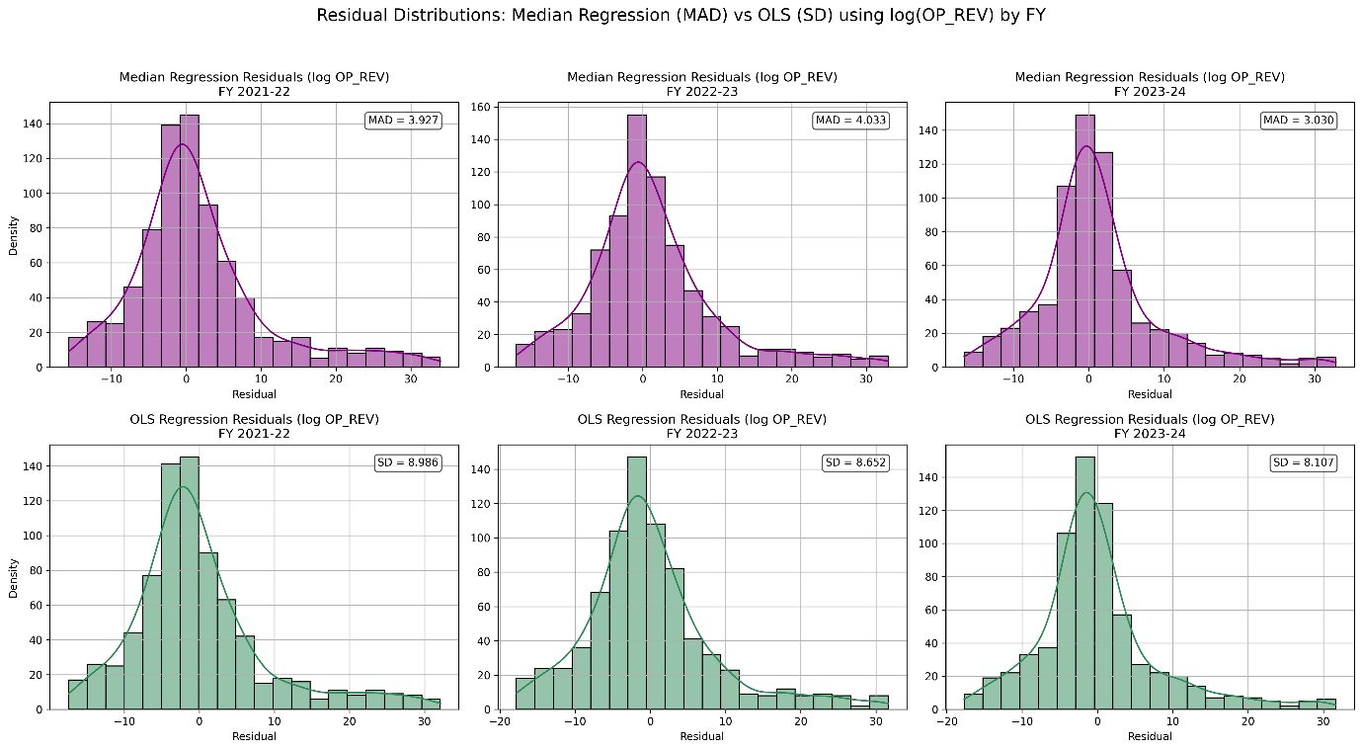

**Interpretation:**

**Direct OR vs PLI (linear form)**

**OLS regression**

* R² values are negligible (<0.003).
* Slopes are statistically insignificant across all years (p-values 0.17–0.83).
* **Inference:** No meaningful association between operating revenue and profitability for export-oriented firms.

**Median regression**

* Slopes are extremely small and non-significant (p-values 0.41–0.91).
* Pseudo-R² values are essentially zero.
* **Inference:** The direct OR–PLI relationship vanishes entirely in this export-focused cohort.

**Log(OR) vs PLI (functional transformation)**

**OLS regression**

* FY 2021-22 shows a weakly significant slope (p ≈ 0.04, R² ≈ 0.005).
* FY 2022-23 and 2023-24 are statistically insignificant (p-values 0.64–0.95).
* **Inference:** OLS provides inconsistent and unstable results.

**Median regression**

* FY 2021-22: Positive, significant slope (p ≈ 0.0017) with modest pseudo-R² (0.006).
* FY 2022-23: Positive, weaker but still significant slope (p ≈ 0.022).
* FY 2023-24: No relationship at all (slope ≈ 0, p ≈ 1.0).
* Residual MAD (≈3.0–4.0) is consistently much lower than OLS residual SD (≈8.1–9.0), showing better stability.
* **Inference:** Median regression with log(OR) captures some positive size–profitability link in the first two years, but the effect disappears completely in the most recent year.

**Overall takeaway for Scenario 3**

* Export-oriented firms show **no reliable relationship** between direct OR and profitability.
* Median regression with log(OR) offers **partial explanatory power** in earlier years, but the relationship breaks down in FY 2023-24.

**Prediction Table:**

Based on the analysis, the median regression with log(OR) emerges as the most significant and robust model. Accordingly, the following table presents predicted PLI values generated from this model for different levels of Operating Revenue (Op_Rev).

